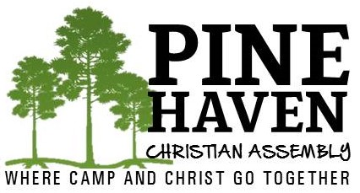
16508 Hwy 87Park RapidsMN56470
2187329419 (JUN–SEP)
2183661391 (OCT-MAY)
phca@pinehavencamp.org

The Annual Meeting for Pine Haven Christian Assembly
shall be held on
January 21, 2023 at 10 AM
at Andover Christian Church
16045 Nightingale St NW, Andover MN 55304.

PHCA is an extension of the ministry of the Christian Churches of Minnesota and South Dakota. Pine Haven Christian Assembly is a treasure and the reason is directly related to the blessing of God that comes when congregations minister together with singleness of heart and mind. The annual meeting of Pine Haven Christian Assembly is a key time for us to get together to report on the ministry of the camp AND to give thanks to God for His rich blessing.

At our annual meeting we will be voting on 3 Board of Director seats. Each year, 3 positions expire (2 lay positions, 1 minister position). This year Ben Piotrowicz (lay), and Joe Cachiaras (lay) and Brad Korell (minister) have all agreed to continue their service, if elected.

The board may approach candidates to consider becoming a board member, and you may desire or know of people who also would be willing to make a commitment to serving the churches through this ministry. If you would like to share contact information of someone you would like to recommend prior to the annual meeting, please contact Ben Piotrowicz at onlyonebp@yahoo.com or by phone at 507-254-7205 or Brad Korell at bwk_75@yahoo.com or by phone at 970-712-7355.

Thank you for your love and continued support of Pine Haven Christian Assembly.

In Christ,
Ben Piotrowicz
Pine Haven Christian Assembly, Board Chair

Brad Korell
Pine Haven Christian Assembly, Board Secretary

